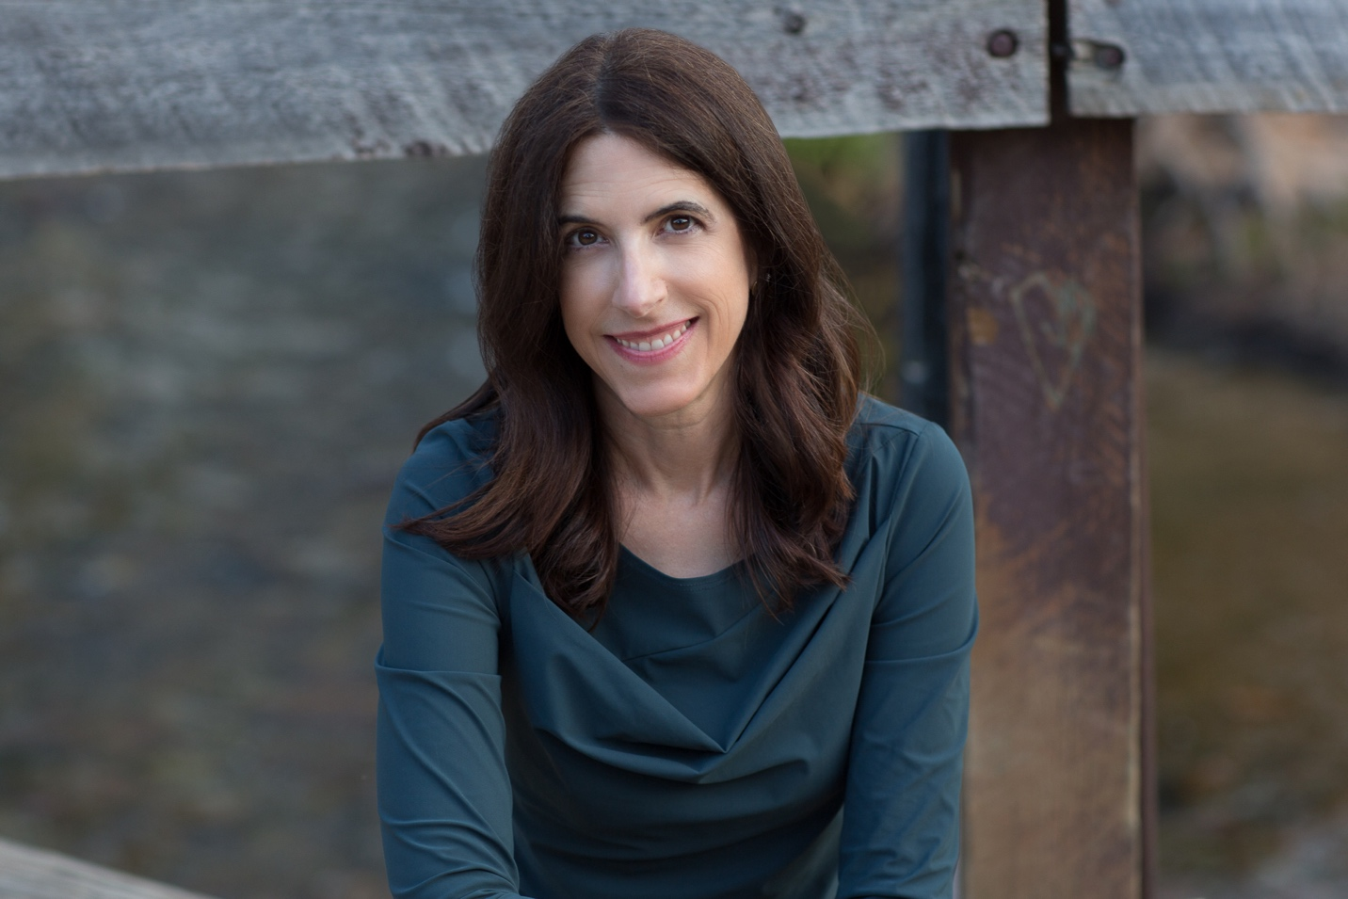

Credit Casie Zalud

SHORT BIO (feel free to edit)

Florence Williams is a journalist, author, and podcaster. Her first book, *BREASTS: A Natural and Unnatural History*received the *Los Angeles Times* Book Prize in science and technology and the 2013 Audie in general nonfiction. *The Nature Fix* was an Audible bestseller and was named a top summer read by J.P Morgan. Her latest book, *Heartbreak*, was called “show-stopping” and “courageous” by *Publisher’s* Weekly and won the 2023 PEN AMERICA award for literary science writing. She is a contributing editor at *Outside Magazine* and a freelance writer for the *New York Times* and numerous other publications. A fellow at the Center for Humans and Nature and a visiting scholar at George Washington University, Florence’s work focuses on the environment, health and science. A certified forest-bathing guide and experienced workshop leader, Florence loves leading groups through both short and multi-day nature-immersive experiences and watching the transformation, connection, and healing that result.

LONGER BIO (feel free to edit as needed)

Florence Williams is a journalist, author, and podcaster. She is a contributing editor at *Outside Magazine* and a freelance writer for the *New York Times*, *New York Times Magazine*, *National Geographic,* *The New York Review of Books* and numerous other publications.

Florence’s first book, *BREASTS: A Natural and Unnatural History  (*W.W. Norton 2012) received the *Los Angeles Times* Book Prize in science and technology and the 2013 Audie in general nonfiction. It was also named a notable book of 2012 by the*New York Times*. Her 2017 book, *The Nature Fix*, was an Audible bestseller and was named a top summer read by J.P  Morgan. Her latest book, *Heartbreak: A Personal and Scientific Journey*, is called “show-stopping” and “courageous” by Publisher’s Weekly and won the 2023 PEN AMERICA award for literary science writing. She is also the writer and host of two Gracie-Award-winning Audible Original series, *Breasts Unbound* and *The Three-Day Effect*, as well as numerous episodes for *Outside Magazine*’s podcast. The *Wall Street Journa*l calls her writing “droll and crisp,” which makes her feel like a pastry.

Her public speaking includes keynotes at Google, the Smithsonian, the Seattle Zoo, the Aspen Ideas Festival and many other corporate, academic and nonprofit venues. A fellow at the Center for Humans and Nature and a visiting scholar at George Washington University in Washington, D.C., Florence’s work focuses on the environment, health and science. A certified forest-bathing guide and experienced workshop leader, Florence loves leading groups through nature-immersive experiences and watching the transformation, connection, and healing that results.

A former Scripps Fellow at the Center of Environmental Journalism at the University of Colorado, she has received many awards, including two National Magazine Award nominations, six magazine awards from the American Society of Journalists and Authors, and the John Hersey Prize at Yale. Her work has been anthologized in numerous books, including *Outside 25*, the *New Montana Story*, *How the West Was Warmed* and *Best American Science and Nature Writing 2008*. Florence serves on the board of two of her favorite non-profits, the Trust for Public Land and the Ted Scripps Fellowship in Environmental Journalism.

[www.florencewilliams.com](http://www.florencewilliams.com)

<https://twitter.com/flowill>

<https://www.instagram.com/florence999/>

<https://www.facebook.com/florencewilliamsauthor>

<https://mastodon.social/@Flowill>

**TALK Descriptions:**

**Your Brain on Nature: Why Being Outside Makes us Feel Happier, Healthier, and More Creative**

Florence Williams, nationally acclaimed journalist and author, will present the latest evidence on the science behind why nature is good for us, from cognition to mental health. She incorporates reporting and research from around the world, from Japan to Scotland to Singapore to Utah for insights into how being nature changes our brains and physiologies. What constitutes exposure to nature? What is the dose for optimal benefit and how are doctors and patients medicalizing time in parks? What she learned holds many lessons for interacting with the natural world in good times and bad.

**Your Brain on Nature**

Science journalist Florence Williams will discuss the latest research on why getting outside is good for human health, wellbeing and creativity. She draws from neuroscience, environmental psychology, cognition studies, epidemiology and medicine around the world. Learn why our current epidemic disconnection from nature threatens our communities and what we can do about it.

**Nature-Time and The Power of Awe**

Science journalist Florence Williams explores the latest research from around the world on how nature immersion and experiencing awe on a regular basis can help us find resilience from stress. How can cultivating beauty and connecting to nature help us deal with climate grief and increase our capacity to work together to solve problems? Learn how the surprising Power of Awe can help us with both personal and collective challenges in times both good and bad.

(BOOK JACKET PHOTOS BELOW)



